Pls contact us :35007117@ qq.com
---------------------------------------------------------
Linner Hall
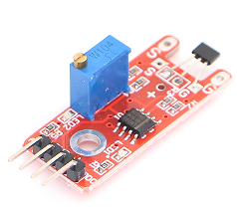
Linner Hall module can connect UNO R3 PIN13, make magnetic test.
Pin 13’s LED，use magnetic module connect Pin 3. When hall module test there is magnetic, led can be bright.

Code:
int Led=13;//Define LED interface
int buttonpin=3; //Definition of linear Holzer magnetic sensor interface
int val;//Define numeric variable val
void setup()
{
pinMode(Led,OUTPUT);//Define LED as output interface
pinMode(buttonpin,INPUT);/Definition of linear Holzer force sensor for output interface
}
void loop()
{
val=digitalRead(buttonpin);//Read the value of the value of the digital interface 3 to val
if(val==HIGH)/When the linear Holzer magnetic sensor detects the signal, the LED flashes
{
digitalWrite(Led,HIGH);
}
else
{
digitalWrite(Led,LOW);
}
}

